Pointer Club of Scotland’s Summer Grouse trials 2021 Results

The Pointer Club of Scotland’s annual Summer Grouse field trials for Pointers and Setters took place on the magnificent Cawdor Estate, Nairnshire, by kind permission of Lord Cawdor, on August 2/3,2021.

The trials were judged by Mr Andy Law and Mr Bill Connolly. This moor is outstanding for Pointer and Setter work and has 40,000 acres of rolling heather moorland. The Headkeeper, Paul Wilson went the extra mile to ensure the trials were successful.

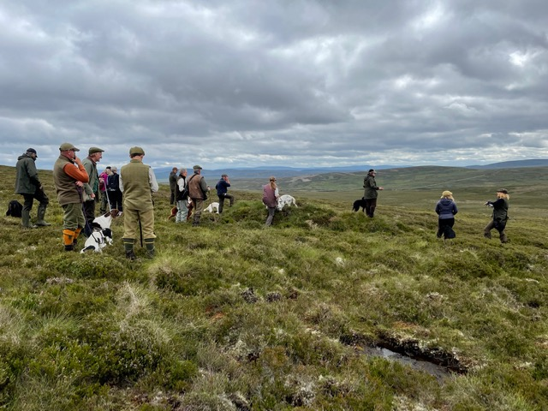

A presentation was made on behalf of the club to Richard MacNicol who retired as Field Trial Secretary after 28 years. The new Field Trial Secretary is John Tibbs.

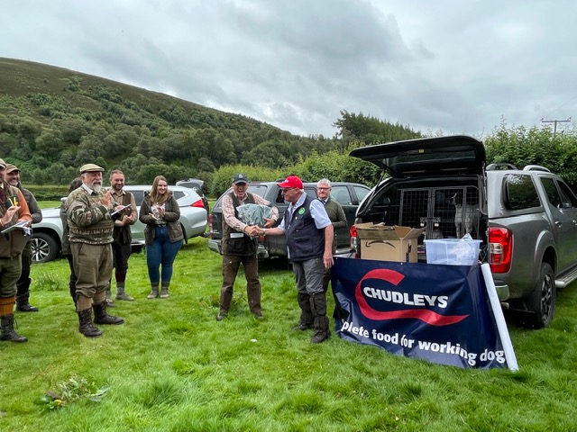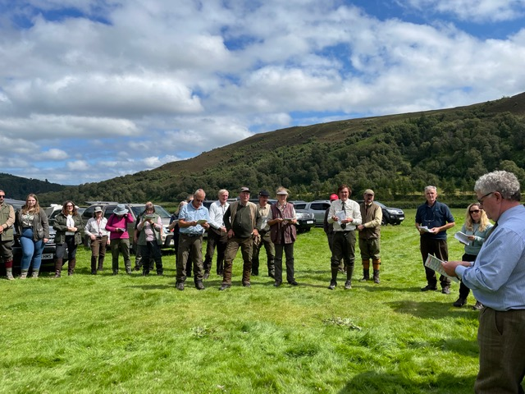
RESULTS
Novice Stake - Monday August 2, 2021
1st Doug Collins Irish Setter bitch Ballyellen Joy.
2nd Lester Anderson’s Pointer dog Fowington Harris.
3rd Brian Morris’ Irish Setter dog Ballyellen Spider.
Open Stake - Tuesday August 3, 2021
1st Brian Morris’ Irish Setter dog FT CH Erinvale Mountain.
2nd Sara Chichester’s Irish Setter dog Dunroon Ginger Storm of Wiscombe.

