Obituary – Elizabeth Jean Eppie Buist

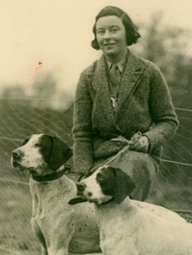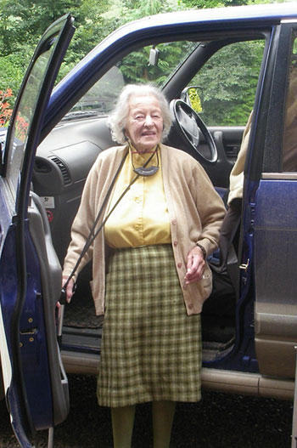

Eppie Buist , the Grand Old Lady of the Pointer and Setter world, who died on September 24 aged 98, was the longest serving field trial secretary ever. Eppie was secretary of the Northern Counties Pointer and Setter Society for 60 years.

Dornoch Cathedral was full to capacity where hundreds of people gathered to celebrate her life on October 2, 2008. The service was conducted by Rev Susan Brown and assisted by Rev Charlie Robertson. The congregation shared many joyous memories of Eppie’s unique life. The order of service had a beautiful picture of Eppie with two of her beloved pointers. Beneath the photograph was a verse which to me summed up Eppie’s life in a nutshell:

“A life well lived is a precious gift
Of hope and strength and grace
From someone who has made our world
A brighter better place”

The local retired minister Rev Charlie Robertson said he had known Eppie for a very long time indeed. He visited her home at Katewell near Dingwall. He said, to howls of laughter in the Cathedral: “ Many times I would call in to visit Eppie and invariably on the cooker would be a huge pot bubbling away with bones for the dogs. Outside in the garden there would be green tripe hanging on the washing line!!”

Eppie was born on April 10, 1910. On reaching the age of 21, Eppie’s father,Sir Robert W. Brooke, Bart., gifted her a kennel of 64 dogs. In the 1930s the famous Elhew kennel in America purchased a Pointer bitch called Gem of Fearn (Isle of Arran Fleet x Lorna of Fearn) as the foundation of the Elhew Pointers. Eppie’s Kennel Club prefix was Fearn and the Fearn line will continue under Jim Howden. There have been many Fearn pointers to grace the pages of the Kennel Club Stud

Book over the years. Fearn Pointers were hired out to shooting estates all over Scotland.

Her sporting life was long and varied. She went stalking well into her 70s and continued to spectate at field trials right up until August of this year when she attended the Champion Stake for Pointers and Setters. Eppie was a prolific letter writer. Her last letter to me was dated August 17,2008. The final paragraph stated: “Hope you can read this epistle as I have lost my glasses. When you have time do come up for a day or two and we can browse on pedigrees.” Sadly I never made it on time.

Eppie is survived by her two daughters Mary and Jane, and four grandchildren.

