In addition to the list of books on the Pointer Breed and training, we include a selection of other books which may be of interest to Pointer and countryside lovers.

 | Damien Lewis’s book tells the impossibly moving story of how Pointer Judy, World War Two's only animal POW, brought hope in the midst of hell.
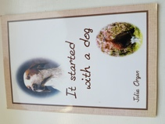 | This little book written by Julie Organ describes how she became involved with Pointers and showing and trialling over several decades. It is now out of print but available as a Kindle download on Amazon.
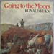 | In his book ‘Going to the Moors’, Ronald Eden the son of Lady Auckland of the famous Cromlix kennels recalls the late 18th- and early 19th-century excursions north of the Border by hardy English sportsmen, willing to endure spartan conditions of travel and accommodation. Although out of print, used copies can sometimes be sourced online
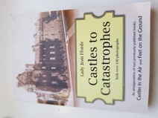 | This book is an amalgamation of two previously published books by Lady Jean Fforde, our club’s late President. Lady Jean’s book provides an insight into her life and that of her family through the changes of 20th Century Britain. Chapter 14 , where Lady Jean describes the sporting life on Arran, will be of particular interest to Pointer and Setter enthusiasts
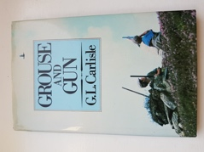 | G.L. Carlisle’s book describes all aspects of a grouse shoot – the different types of moorland and their management, the varieties of species to be found on a moor and the duties and responsibilities of the keepers and guests attending a shoot
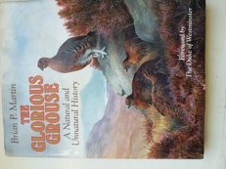 | In this book Brian Martin describes every aspect of the red grouse, its natural history and as a quarry species. The book contains a number of photographs and illustrations
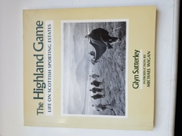 | Glyn Satterley is one of Scotland’s most respected wildlife and countryside photographers. A link to his website can be found in the Links section of our site where you can see the full listing of his compilations of beautiful photographs.

