Several excellent books have been written about the Pointer breed over the years. Unfortunately most are out of print however used copies often become available on websites such as Amazon or eBay
https://www.ebay.co.uk › Books-Comics-Magazine

so we consider it worthwhile featuring these here.

 | William Arkwright’s book was first published in 1906. It is an illustrated history of the pointing dog from the earliest times. It contains a number of early paintings and engravings by famous artists.
 | The Pointer by Cicely Robertshaw and Kitty Edmondson of the famous Crookrise Kennels was first published in 1978. Pointers Past and Present was a later publication.
 | For anyone interested in training their dog for work and how to go about the job, this is an excellent book with illustrations. First published in 1973,it is written mainly for inexperienced enthusiasts.
 | First published in 1974, written by Dr J.B.Maurice it guides the prospective owner from choosing a puppy, domestication to early stages in its training. The book includes a useful glossary and a list of dos and don’ts from which every handler will benefit.
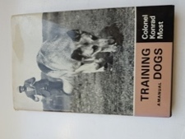 | Col Konrad Most’s book is recommended for experienced and novice trainers of any kind of dog who will benefit by reading it. First published in the UK in 1954.
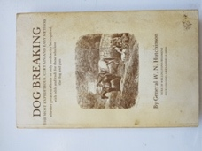 | First published in the mid 1800s, General Hutchinson’s book may be of interest to those gundog owners who enjoy the historic aspects of training.
 | David Hudson’s book is a comprehensive guide to Pointers and Setters. The author looks at how the breeds originally evolved and how they developed into the working, showing and pet dogs we know today. First published in 2004.
 | Ledgands have published two limited edition Pointer compendiums in a photographic format along with 5 generation pedigrees of the featured dogs. Copies can be purchased direct from the author’s website. https://www.ledgands.co.uk/shop/

